* Architecture Overview
* ConvNet layer
  + Convolutional layer
  + Pooling layer
  + Normalization layer
  + Fully – connected layer

Convolutional Neural Network are very similar to ordinary Neural Networks, they are made up of neurons that have learnable weights and biases. Each neuron receive some inputs, performs a dot product and optionally follows it with a non-linearity. The whole network still expresses a single differentiable score function: from the raw image pixels on one end to class scores ate the other. And they sill have loss function (e.g. SVM/Softmax) on the last (fully-connected) layer and all the tips/tricks we developed for learning regular Neural Networks still apply.

So what changes? ConvNet architectures make the explicit assumption that the inputs are images, which allows us to encode certain properties into the architecture. These then make the forward function more efficient to implement and vastly reduce the amount of parameters in the network.

Architecture overview

As we known, Regular Neural Networks receive an input (a single vector), and transform it through a series of *hidden layers*. Each hidden layer is made up of a set of neurons, where each neuron is fully connected to all neurons in the previous layer, and where neurons in a single layer function completely independently and do not share any connections. The last fully-connected layer is called the “output layer” and in classification settings it represents the class scores.

However, Regular Neural Nets don’t scale well to full images. For examples, with an images only size of 32x32x3 (32 wide, 32 high, 3 color channels), a single fully – connected neuron in a first hidden layer of a regular Neural Network would have 32*32*3 = 3072 weights. But with an image of more respectable size, for example: 200x200x3, would lead to neurons that have 200*200*3 = 120000 weights. Moreover, we would almost certainly want to have several such neurons, so the parameters would add up quickly! Clearly, this full connectivity is wasteful and the huge number of parameters would quickly lead to overfitting.

Convolutional Neural Networks take advantage of the fact that the input consists of images and they constrain the architecture in a more sensible way. In particular, unlike a regular Neural Network, the layers of a ConvNet have neurons arranged in 3 dimensions: **width, height, depth**. Moreover, the final output layer would for CIFAR-10 have dimensions 1x1x10, because by the end of the ConvNet architecture we will reduce the full image into a single vector of class scores, arranged along the depth dimension. Here is a visualization:

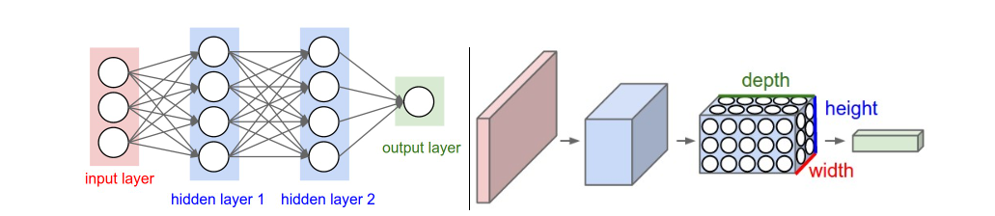

Left: A regular 3-layer Neural Network. Right: A ConvNet arranges its neurons in three dimensions (width, height, depth), as visualized in one of the layers. Every layer of a ConvNet transforms the 3D input volume to a 3D output volume of neuron activations. In this example, the red input layer holds the image, so its width and height would be the dimensions of the image, and the depth would be 3 (Red, Green, Blue channels).

Layers used to build ConvNets

As we described above, a simple ConvNet is a sequence of layers, and every layer of a ConvNet transforms one volume of activations to another through a differentiable function. We use three main types of layers to build ConvNet architectures: **Convolutional Layer**, **Pooling Layer**, and **Fully-Connected Layer** (exactly as seen in regular Neural Networks). We will stack these layers to form a full ConvNet **architecture**.

We will go into more details below, but a simple ConvNet for CIFAR-10 classification could have the architecture [INPUT - CONV - RELU - POOL - FC]. In more detail:

* INPUT [32x32x3] will hold the raw pixel values of the image, in this case an image of width 32, height 32, and with three color channels R,G,B.
* CONV layer will compute the output of neurons that are connected to local regions in the input, each computing a dot product between their weights and a small region they are connected to in the input volume. This may result in volume such as [32x32x12] if we decided to use 12 filters.
* RELU layer will apply an elementwise activation function, such as the max(0,x) thresholding at zero. This leaves the size of the volume unchanged ([32x32x12]).
* POOL layer will perform a downsampling operation along the spatial dimensions (width, height), resulting in volume such as [16x16x12].
* FC (i.e. fully-connected) layer will compute the class scores, resulting in volume of size [1x1x10], where each of the 10 numbers correspond to a class score, such as among the 10 categories of CIFAR-10. As with ordinary Neural Networks and as the name implies, each neuron in this layer will be connected to all the numbers in the previous volume.

In this way, ConvNets transform the original image layer by layer from the original pixel values to the final class scores. Note that some layers contain parameters and other don’t. In particular, the CONV/FC layers perform transformations that are a function of not only the activations in the input volume, but also of the parameters (the weights and biases of the neurons). On the other hand, the RELU/POOL layers will implement a fixed function. The parameters in the CONV/FC layers will be trained with gradient descent so that the class scores that the ConvNet computes are consistent with the labels in the training set for each image.

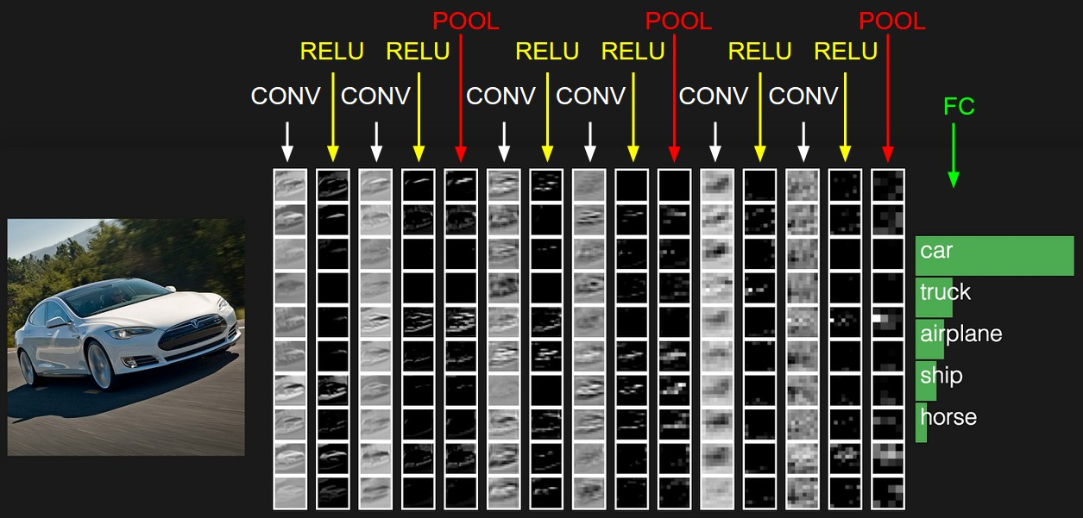

Convolutional Layer

The Conv layer is the core building block of a Convolutional Network that does most of the computational heavy lifting.

Zero padding

Stride

**Summary**. To summarize, the Conv Layer:

* Accepts a volume of size W1×H1×D1W1×H1×D1
* Requires four hyperparameters:
  + Number of filters KK,
  + their spatial extent FF,
  + the stride SS,
  + the amount of zero padding PP.
* Produces a volume of size W2×H2×D2W2×H2×D2 where:
  + W2=(W1−F+2P)/S+1W2=(W1−F+2P)/S+1
  + H2=(H1−F+2P)/S+1H2=(H1−F+2P)/S+1 (i.e. width and height are computed equally by symmetry)
  + D2=KD2=K
* With parameter sharing, it introduces F⋅F⋅D1F⋅F⋅D1 weights per filter, for a total of (F⋅F⋅D1)⋅K(F⋅F⋅D1)⋅K weights and KK biases.
* In the output volume, the dd-th depth slice (of size W2×H2W2×H2) is the result of performing a valid convolution of the dd-th filter over the input volume with a stride of SS, and then offset by dd-th bias.

Example:

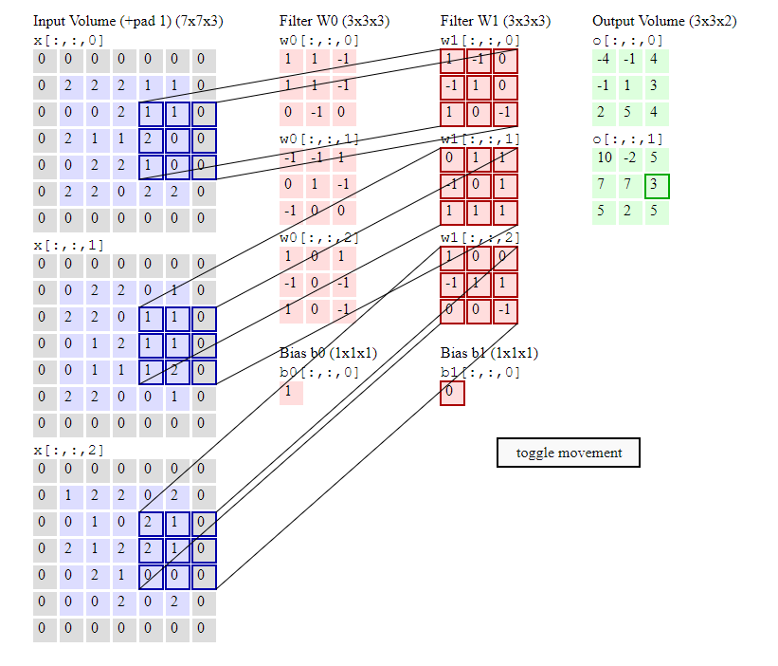

**Pooling Layer**

* Accepts a volume of size W1×H1×D1
* Requires two hyperparameters:
  + their spatial extent F,
  + the stride S,
* Produces a volume of size W2×H2×D2 where:
  + W2=(W1−F)/S+1
  + H2=(H1−F)/S+1
  + D2=D1
* Introduces zero parameters since it computes a fixed function of the input
* For Pooling layers, it is not common to pad the input using zero-padding.

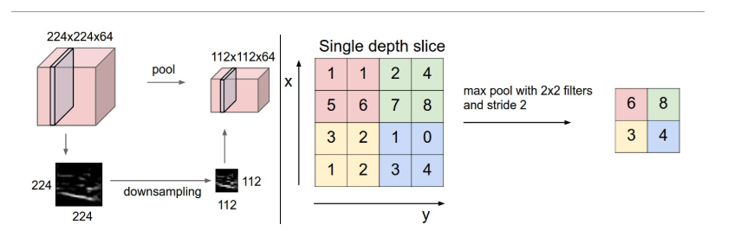

Pooling layer downsamples the volume spatially, independently in each depth slice of the input volume. **Left:** In this example, the input volume of size [224x224x64] is pooled with filter size 2, stride 2 into output volume of size [112x112x64]. Notice that the volume depth is preserved. **Right:** The most common downsampling operation is max, giving rise to **max pooling**, here shown with a stride of 2. That is, each max is taken over 4 numbers (little 2x2 square).

Fully-connected layer

Neurons in a fully connected layer have full connections to all activations in the previous layer, as seen in regular Neural Networks. Their activations can hence be computed with a matrix multiplication followed by a bias offset.

Transfer Learning

In practice, very few people train an entire Convolutional Network from scratch (with random initialization), because it is relatively rare to have a dataset of sufficient size. Instead, it is common to pretrain a ConvNet on a very large dataset (e.g. ImageNet, which contains 1.2 million images with 1000 categories), and then use the ConvNet either as an initialization or a fixed feature extractor for the task of interest. The three major Transfer Learning scenarios look as follows:

* **ConvNet as fixed feature extractor**. Take a ConvNet pretrained on ImageNet, remove the last fully-connected layer (this layer’s outputs are the 1000 class scores for a different task like ImageNet), then treat the rest of the ConvNet as a fixed feature extractor for the new dataset. In an AlexNet, this would compute a 4096-D vector for every image that contains the activations of the hidden layer immediately before the classifier. We call these features **CNN codes**. It is important for performance that these codes are ReLUd (i.e. thresholded at zero) if they were also thresholded during the training of the ConvNet on ImageNet (as is usually the case). Once you extract the 4096-D codes for all images, train a linear classifier (e.g. Linear SVM or Softmax classifier) for the new dataset.
* **Fine-tuning the ConvNet**. The second strategy is to not only replace and retrain the classifier on top of the ConvNet on the new dataset, but to also fine-tune the weights of the pretrained network by continuing the backpropagation. It is possible to fine-tune all the layers of the ConvNet, or it’s possible to keep some of the earlier layers fixed (due to overfitting concerns) and only fine-tune some higher-level portion of the network. This is motivated by the observation that the earlier features of a ConvNet contain more generic features (e.g. edge detectors or color blob detectors) that should be useful to many tasks, but later layers of the ConvNet becomes progressively more specific to the details of the classes contained in the original dataset. In case of ImageNet for example, which contains many dog breeds, a significant portion of the representational power of the ConvNet may be devoted to features that are specific to differentiating between dog breeds.
* **Pretrained models**. Since modern ConvNets take 2-3 weeks to train across multiple GPUs on ImageNet, it is common to see people release their final ConvNet checkpoints for the benefit of others who can use the networks for fine-tuning. For example, the Caffe library has a [Model Zoo](https://github.com/BVLC/caffe/wiki/Model-Zoo) where people share their network weights.